Stranded

# Overview

## Summary

This is a first-person walking simulator game set in a mysterious alien planet where the player needs to adapt to the complex ecosystem and repair the broken spaceship to return to their homeland.

## Design goals

The strange landscapes drive the player to explore, and they will know more about what happened in the past as they have visited more places and scanned more lost logs. They will be shocked by the truth about other members in the ship, moved by their spirits, and finally experience a sense of satisfaction when they understand the mechanics and achieve their goals.

## Features

No combat

Dynamic environment

Environmental storytelling

Twisted plot

Creatures can be utilized to solve puzzles

Log and collection system

# Story

## Settings

A research spaceship with five people on board accidentally crash-landed on a planet. The ship was severely damaged, and the communication equipment failed, leaving the crew no choice but to explore the planet in search of hope for survival. The planet's strange environment and creatures intrigued the researchers, and the crew brought some of the creatures back to the ship for experimentation. However, these creatures broke out of the experimental cages and attacked four of the crew members, leaving only the log keeper, who stayed in the cockpit, as the sole survivor.

## Main story

The log keeper obtained the experimental records left behind by the other crew members and felt sorrow about what happened. He was determined to continue their research, and resolved to find a way to repair the ship. He will explore the entire planet, documenting its strange creatures and collecting the crew members’ lost logs. The knowledge he gradually accumulated will help him overcome the various obstacles in the environment. Ultimately, after uncovering the hidden secrets of the planet and the truth about the crew members, he will find enough fuel for the ship and set sail with the research results.

Note: there are some conflicts in the description of Settings and Main story.

The ship was severely damaged, why did the log keeper only need to find fuel? Who fixed it?

Why did the members lose their logs on the planet?

Why was the log keeper the only one not hurt? How did he get the records?

The player will raise these questions by the contradiction between log texts and the game environment.

## Characters

### Log Keeper(controlled by player)

responsible for recording the ship’s navigational history, resource inventory, crew status and research progress

has a good relationship with each of the crew

hoping to take the research result and members’ logs to homeland.

### Captain

responsible for controlling the spaceship and field sampling

felt guilty for the crash of the ship due to his own mistake

one-eyed

### Engineer

responsible for the maintainance of the ship

his child passed away from a serious illness before the departure

regret not studying medicine

eldest member of the team

### Researcher

TBD

### Research Assistant

TBD

# Gameplay

## Items

### Detection Goggles

When the player presses the button, the goggles are worn. The HUD displays the names of recorded creatures within the field of view. Point the crosshair at a creature to show detailed information.  
If an unknown creature appears, the player can zoom in or out and take a photo of the creature, recording it in the log system (only when the player is close enough to the creature can the recording be successful).



scanner in *No Man’s Sky*

**

camera in *The Legend of Zelda: Breath of the Wild*

### Loader

Worn on the player’s right wrist. When the player's crosshair is aimed at electronic chips in the environment, pressing the button will cause the device to project a screen above the wrist, displaying the information stored in the chip.



translator in *Outer Wilds*

### Shooter

Used to store captured small creatures. It can either shoot creatures in a parabolic trajectory or use them directly. The storage slots are very limited, and the stored content is displayed on the screen on the left hand. Items can be selected using the scroll wheel.



slinger in *Monster Hunter: World*

## Log system

Players can check the logs inside the spaceship, which include the collected crew information, creatures’ information, and personal journals. The information in the logs will be updated with UI prompts each time they read scattered chips, discover or use new creatures, reach target locations, or trigger specific environmental interactions.



ship log in *Outer Wilds*

## Objective

short term: Find out how to overcome obstacles

final: Collect enough fuel to sail up

bonus: Collect all logs

## Level

## 

# Art

references:

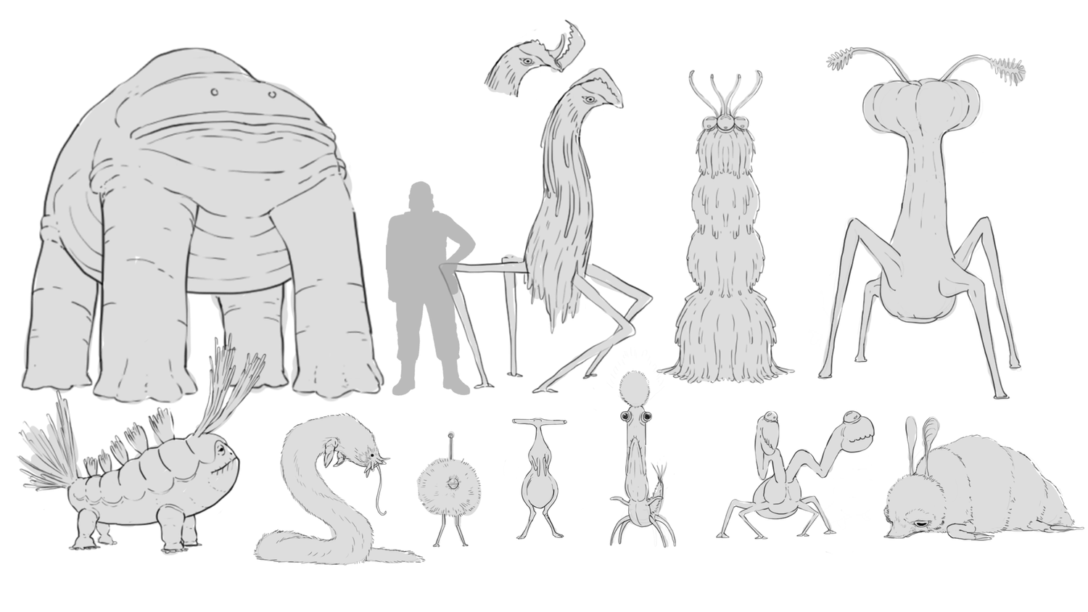

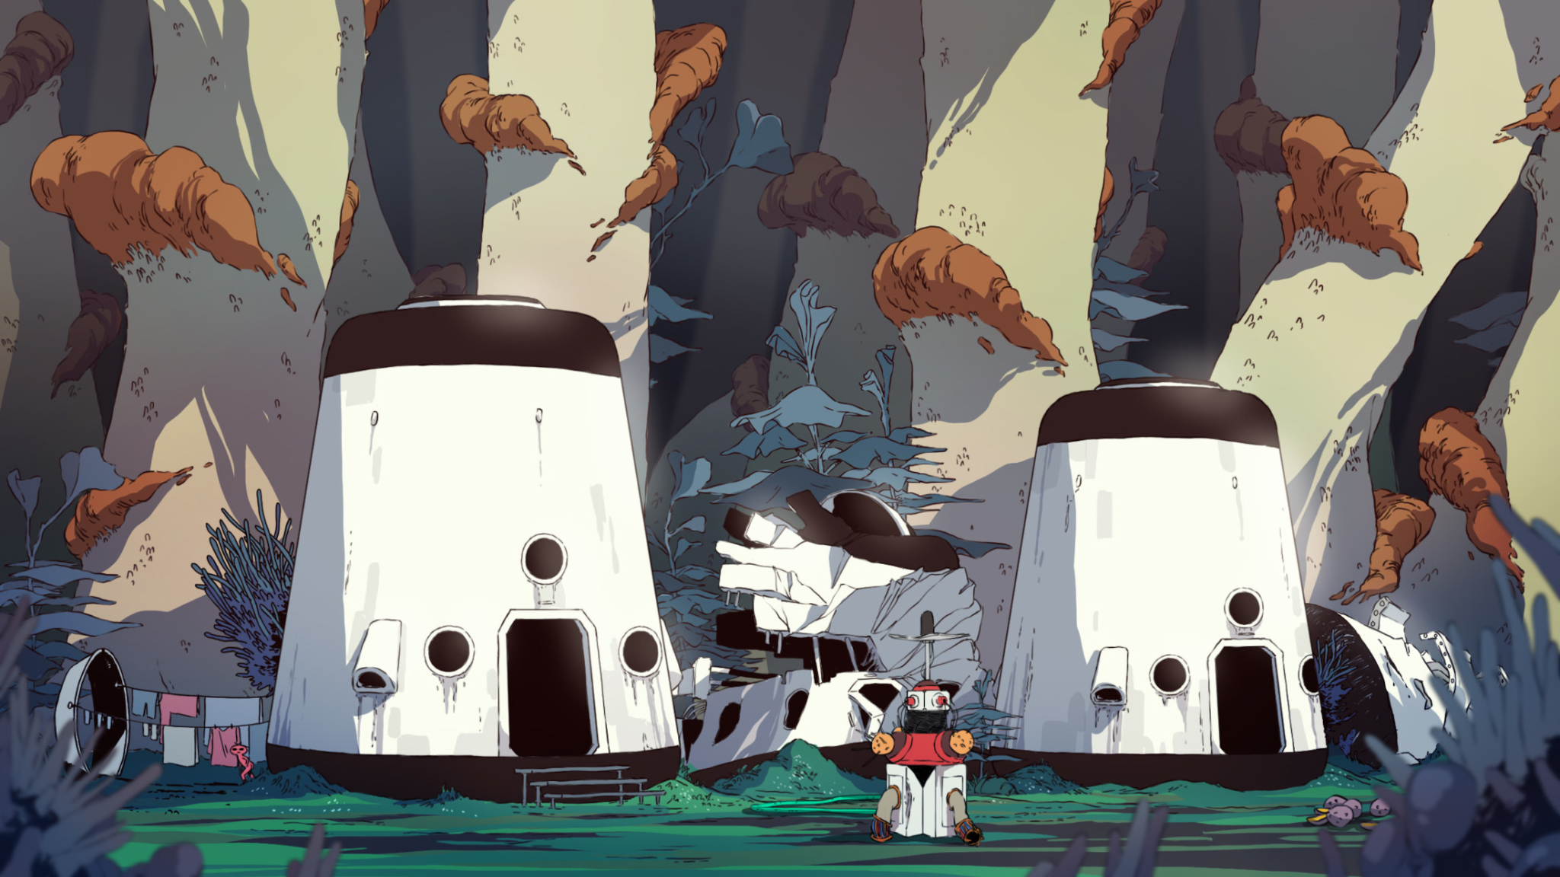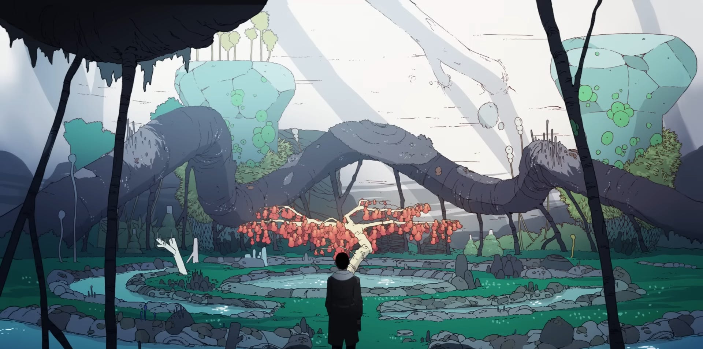

*Scavengers Reign* (Animation Series)

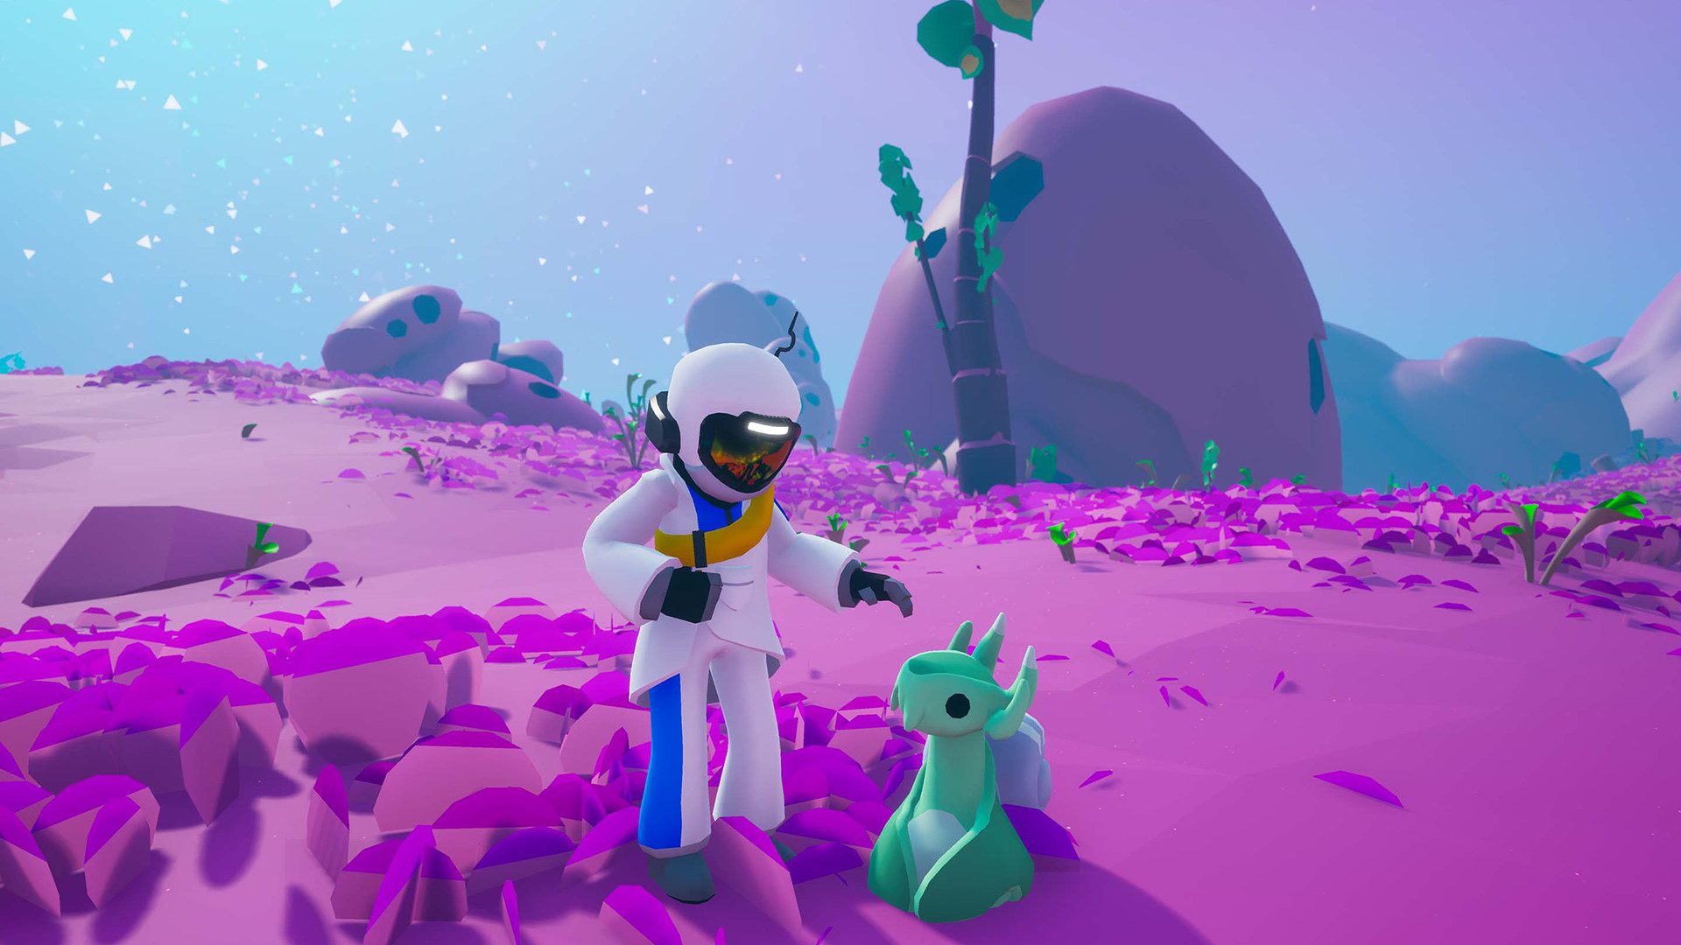

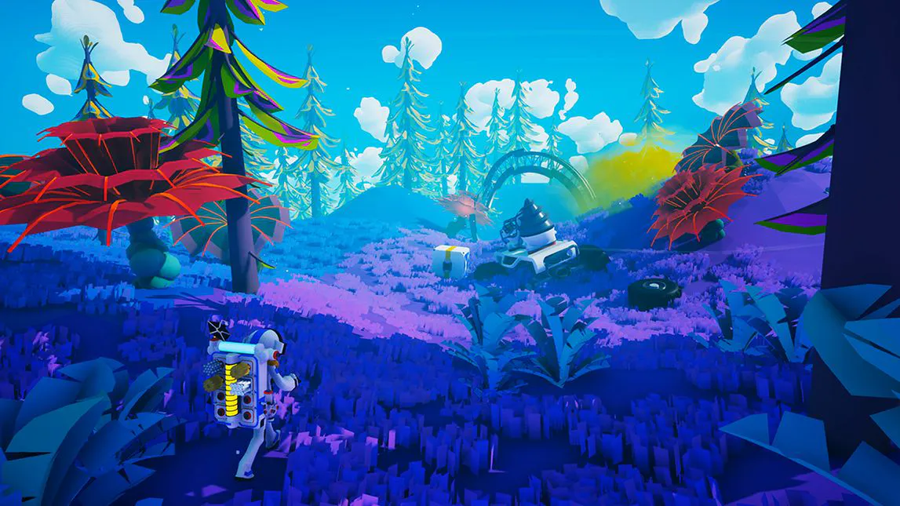

*Astroneer*

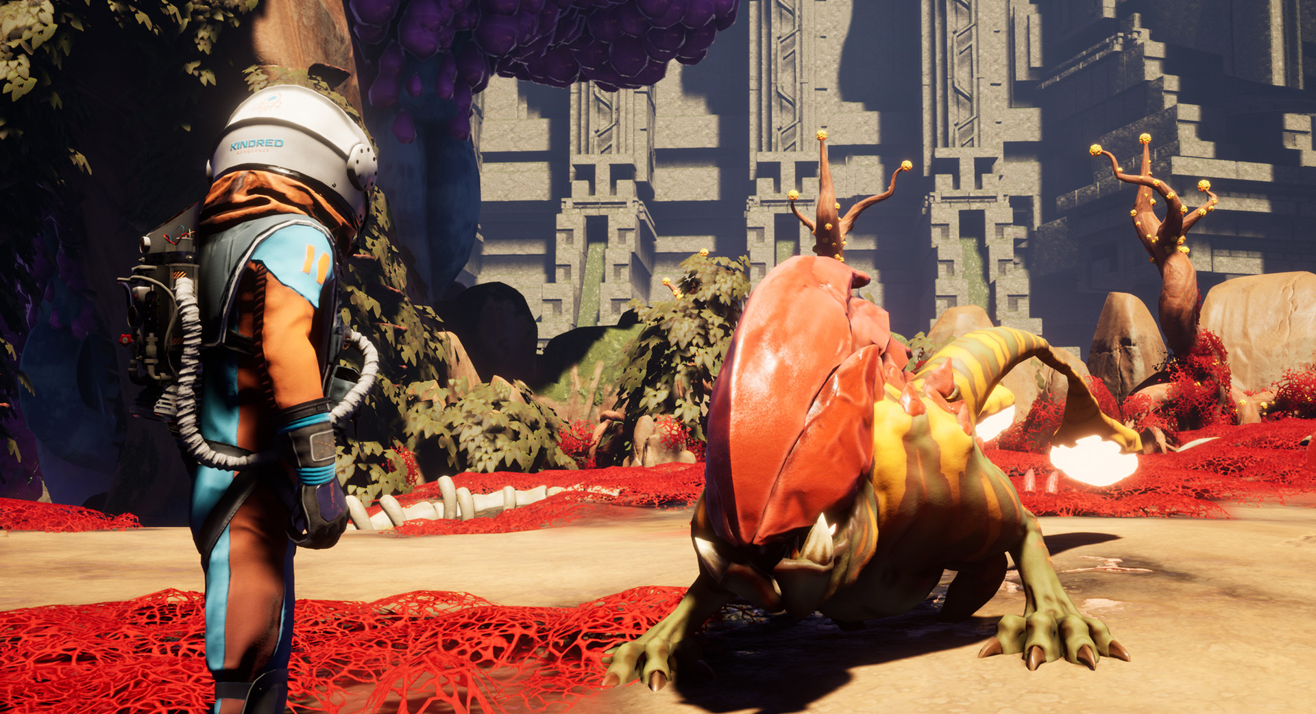

*Journey To The Savage Planet*

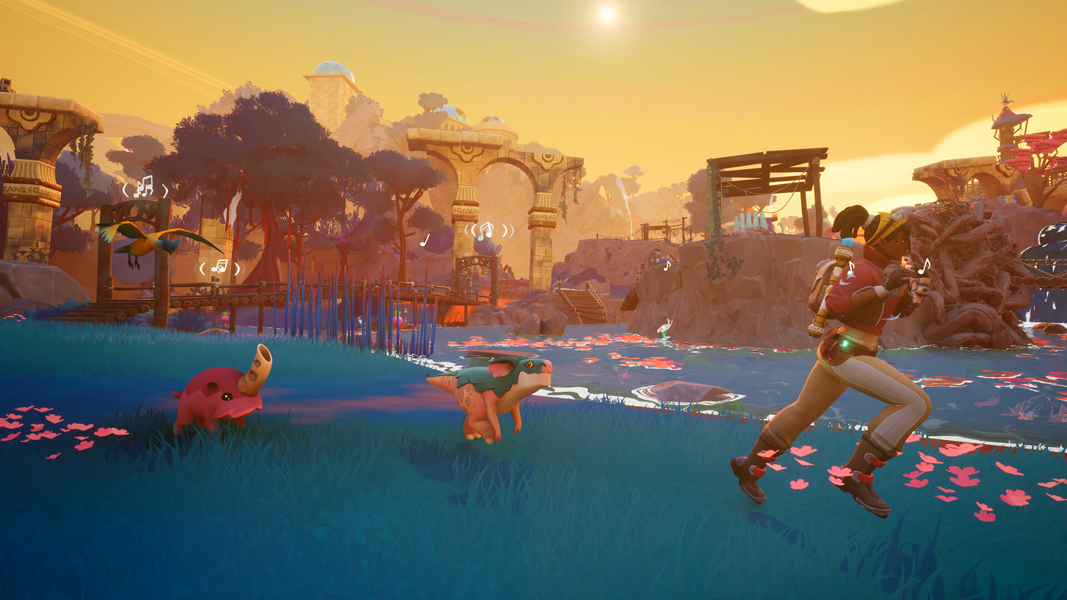

*Creatures of Ava*

# References

*Scavengers Reign*

*Heavenly Delusion*

*Outer Wilds*